NN WELFARE FOUNDATION
LEGACY CATALOGUE
Catalogue Description
The NN Welfare Foundation – Legacy Catalogue serves as an official institutional record of the Foundation’s vision, values, and milestones. It chronicles a journey of compassion transformed into organized service — highlighting the purpose, structure, and achievements of NNF since its inception in 2021. More than a document, it is a reflection of sincerity and faith — designed to preserve institutional memory and inspire future custodians to continue the mission with dignity, discipline, and devotion.
Dedication
This work is dedicated to all those — who give quietly, who serve without recognition, and who find contentment in easing the hardship of others. To the donors whose generosity sustains every act of compassion, to the volunteers whose time and energy turn vision into reality, and to the countless well-wishers whose prayers guide our purpose — this Foundation is a reflection of your faith in goodness. May every life touched through these efforts be a source of blessing, and may this humble endeavour continue to serve humanity with sincerity, dignity, and devotion.
Table of Contents / Version Index
Section | Title | Page No.
1 | Title Page | 1
2 | Catalogue Description | 2
3 | Dedication | 3
4 | Table of Contents / Index | 4
5 | Editorial Note | 5
6 | Preface | 6
7 | Acknowledgements | 7
8 | Core Chapters | 8
9 | Chapter 1 | 9
10 | Chapter 2 | 10
11 | Chapter 3 | 11
12 | Chapter 4 | 12
13 | Founder’s Reflection | 13
14 | In Gratitude | 14
15 | Contact Information | 15

Editorial Note
The NN Welfare Foundation Legacy Catalogue represents a synthesis of faith, transparency, and professional record-keeping. It has been prepared under the supervision of the NN Welfare Documentation Cell, with support from digital volunteers and AI technology, to ensure completeness and archival integrity. This compilation serves both as a report and as a legacy — providing an authentic, accessible reference for donors, partners, and future welfare leaders. It preserves the narrative of how compassion, when institutionalized with accountability, can sustain a movement of hope.
Preface
From the Blessed to the Needy — A Bridge of Hope
The NN Welfare Foundation (NNF) was established to transform personal loss into a life long mission of public service. Guided by faith, discipline, and empathy, the Foundation strives to empower the underprivileged, provide access to education, and restore dignity through sustainability/.
Legacy Declaration
This Legacy Catalogue documents NNF’s evolution from its formative years (2021–2025) — capturing milestones, programmes, and the values that continue to drive its mission. It also serves as a guide for future custodians of the Foundation — to preserve its authenticity, ensure transparency, and uphold the principle of “Service with Dignity.”
Acknowledgements
NN Welfare Foundation extends heartfelt gratitude to its donors, volunteers, and partners whose trust and cooperation have made this record possible. Every chapter of this catalogue reflects their contributions — visible and unseen — that sustain the Foundation’s ongoing service. Special recognition is extended to the Documentation Cell, digital collaborators, and creative volunteers who contributed their time, effort, and technical support to this publication. Their collective sincerity and teamwork reflect the spirit of unity and purpose that defines NN Welfare Foundation.
Core Chapters
CHAPTER 1
ABOUT US

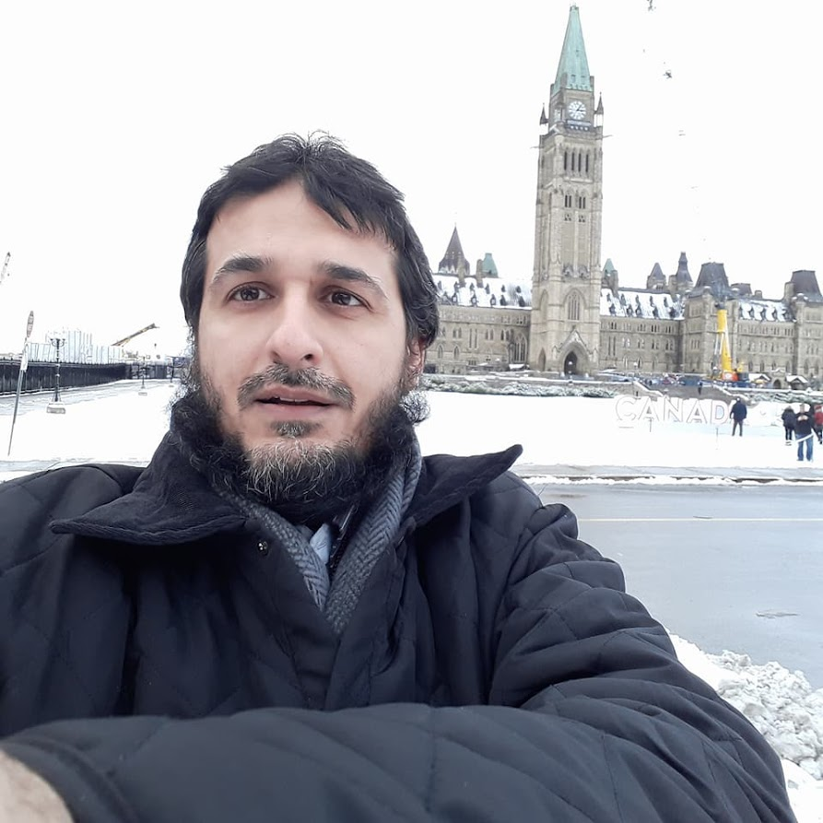
Preface
From the Blessed to the Needy — A Bridge of Hope
NN Welfare Foundation (NNF) was established to convert personal loss into a mission of public service. Born from a founder’s desire to honour loved ones through charitable action, NNF seeks to uplift disadvantaged families and provide pathways to dignity, education, and self-reliance. This catalogue records the early journey, principles, and impact of NNF up to 2025.

1.1 Vision
“The Blessed Amongst us Can Empower, Less Fortunate.”
NNF is a non-profit organization dedicated to helping Zakat-eligible, underprivileged, and marginalized segments of society through welfare and empowerment initiatives.The foundation operates on principles of credibility, compliance, transparency and impactful use of resources.
1.2 Mission
NNF carries the legacy of knowledge, excellence and benevolence, to empower the weak to stand with dignity and honour in society. Our mission includes alleviating poverty, uniting people through compassion and action, and bringing hope to communities in need.

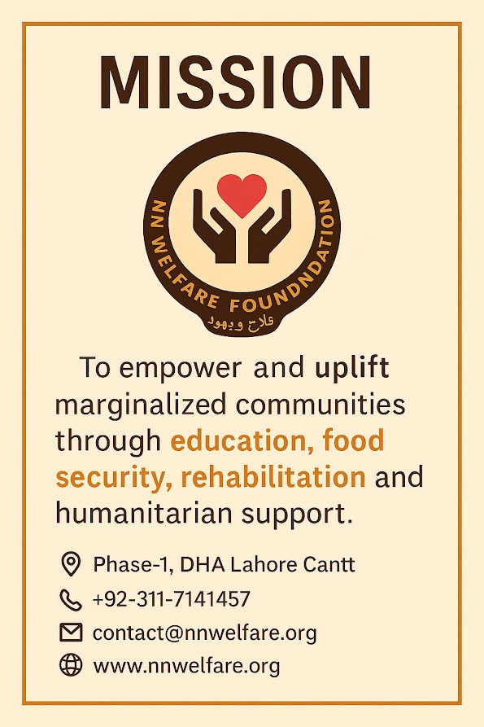
1.3 Core Values
- Credibility: Uphold integrity and diligence.
- Compliance: Operate within legal and regulatory frameworks
- Transparency: Maintain clear records and accountability.
- Impactful: Ensure resources create measurable improvements.
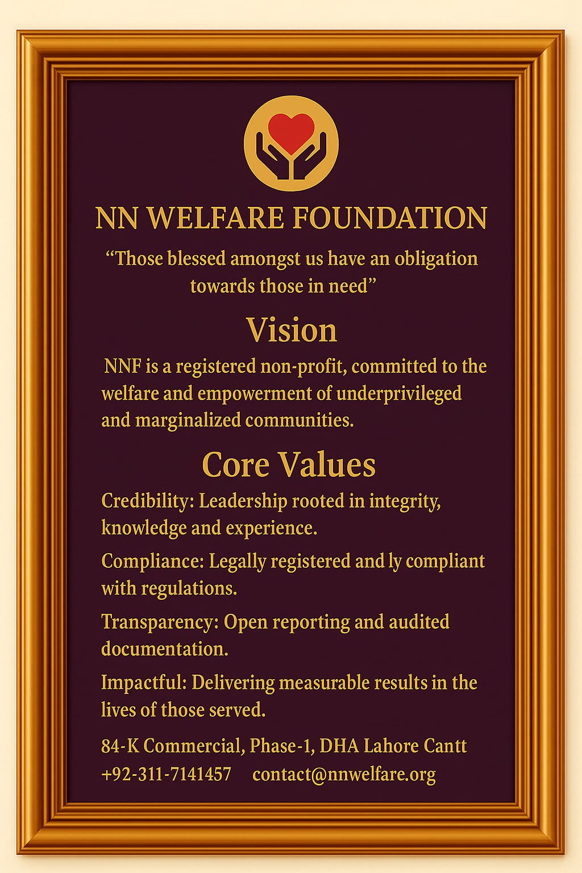
1.4 Foundation History
The founder, Wg Cdr (R) Muazzam Ali Sheikh, transformed personal tragedies into a commitment to public service. After decades of service in the Air Force and educational welfare initiatives, he formally established NN Welfare Foundation on 30 April 2021, which later registered with the Government of Punjab on 11 January 2025. The foundation's growth is the result of donors, volunteers, and dedicated team members working toward sustainable social welfare.

Aims & Objectives
- Empowering Underprivileged.
NNF provides a robust and dynamic social welfare platform with diligence and transparency. Our core focuses include:
a) Empowerment: Helping needy citizens grow as productive members of society.
b) Platform for Donors: Facilitate collection and disbursement of donations.
c) Forum for Volunteers: Induct willing human capital from home and overseas.
d)Fundraising: Mobilize resources to achieve objectives.
e) Collaboration: Partner with government agencies and NGOs.
f) Longevity: Encourage youth engagement and mentoring for sustained impact

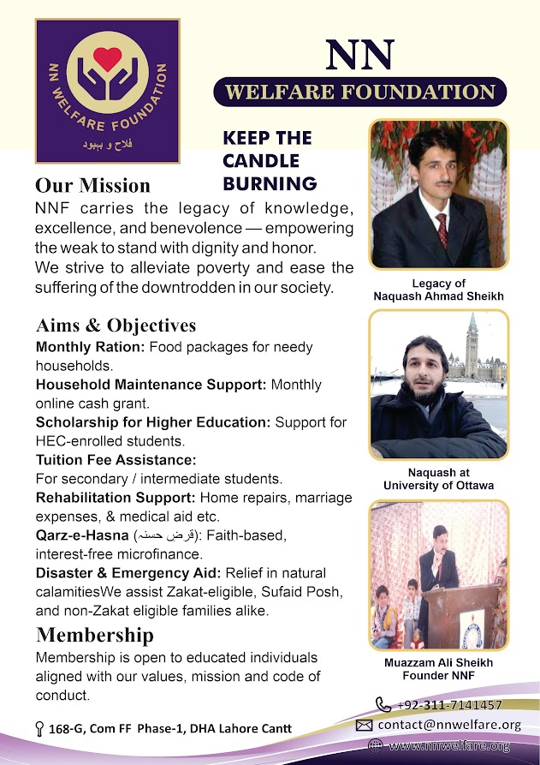

2.2 Our Services
NNF supports a range of services including monthly rations, household maintenance support through cash transfers, scholarships for merit-based higher education, tuition assistance for school and college students, rehabilitation, disaster relief, and Qarz-e-Hasna — faith-driven, interest-free microfinance for entrepreneurship and job creation.

Achievements
3.1 Key Milestones (2021–2025)
Over four years, NNF has grown from a small trust into a registered foundation, completing constitution framing, establishing an executive body, and receiving certifications from governmental bodies. Notable achievements include ongoing monthly support to numerous families, merit scholarships to HEC-recognized university students, collaborative relief efforts with larger NGOs, and regular public disclosure of donations and expenditures.

Future Goals
4.1 Strategic Priorities
NNF plans to expand its reach, scale up support programs, enlarge scholarship offerings, and strengthen emergency response capabilities. Strategic priorities include capital building, good governance with automation, harnessing social media for outreach, and nurturing youth involvement through mentoring by veterans.

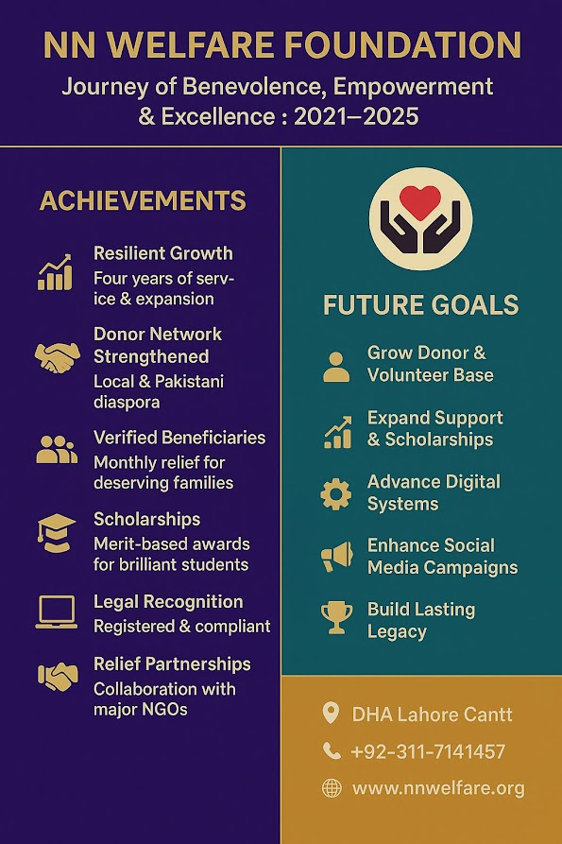
Success Stories

5.1 Career Building with Excellence — Umar Waseem
Umar Waseem received scholarship support to complete his engineering degree and now works as a project engineer. Inspired by NNF's vision, he volunteers to support students and assists in digitalizing NGO processes for online registration and documentation.
5.2 Empowering Families — Mrs. Khalida
Mrs. Khalida's household benefited from a modest donation that enabled the installation of a solar power unit, providing reliable electricity and freeing up funds for her children's education.
5.3 Empowering Families — Mrs. Rabia
Mrs. Rabia, a hospital attendant, received donor support to complete her home's basic structure, reducing rental burdens and enabling investment in her children's education.
5.4 Microfinance Makes a Big Difference — Mr. Boota
Mr. Boota, an auto rickshaw driver, refurbished his vehicle with microfinance support, restoring his income-generating capacity and improving household stability.
Legacy Declaration:
NN Welfare Foundation concludes this chapter of its journey with steadfast resolve to continue serving the vulnerable with compassion and dignity. This catalogue captures our beginnings and charts a path for future growth, grounded in faith, transparency, and community partnerships.

CHAPTER 2
CORE PROGRAMMES AND SERVICES
“Serving Communities with Faith, Compassion, and Transparency.”
"Humanity is our purpose, service is our path." – Founder, NN Welfare Foundation

Introduction
NN Welfare Foundation (NNF) is a registered non-profit organization dedicated to improving the quality of life for deserving individuals and families. The Foundation operates under the principles of faith, compassion, and transparency—delivering structured welfare programmes that address core human needs. Each initiative is designed to bring stability, dignity, and empowerment to society’s most vulnerable members.
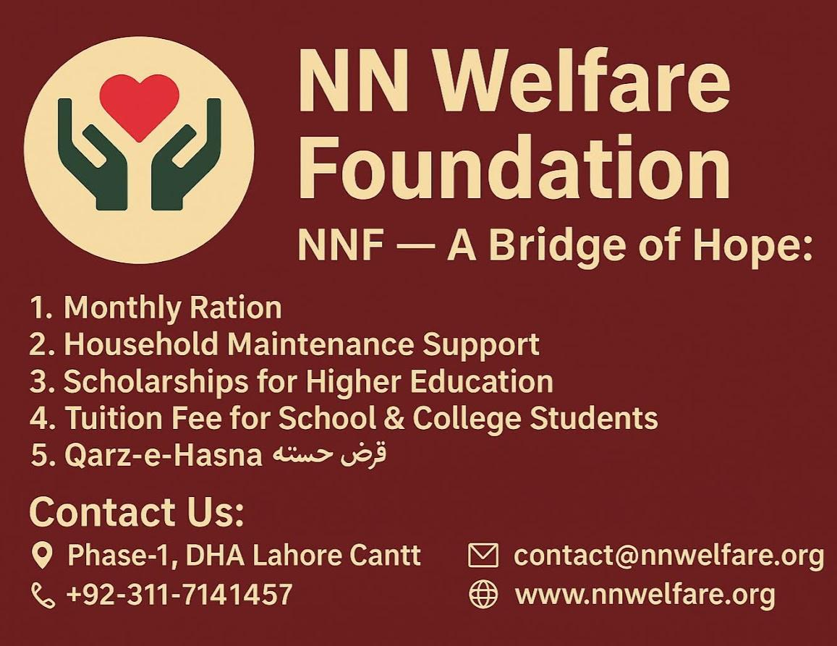
Figure 1: NN Welfare Foundation — A Bridge of Hope
Monthly Ration Support
Through the Monthly Ration Support Programme, NNF provides consistent food security to underprivileged families. Each registered household receives a monthly ration package worth Rs. 5,000, containing essential items such as flour, rice, pulses, and cooking oil. The programme follows a strict verification process to ensure that only zakat-eligible and financially vulnerable families benefit. All distributions are recorded and carried out respectfully, maintaining beneficiaries’ privacy.
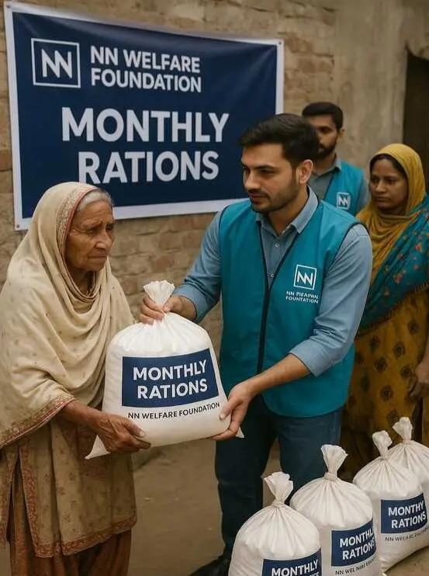
Figure 2 : Monthly ration distribution by NN Welfare Foundation
Household Maintenance Support
This programme provides Rs. 5,000 in monthly financial aid to families who struggle to meet essential household expenses. The support is used to pay rent, utilities, and other necessary costs, reducing the burden on low-income families. Through this initiative, NNF aims to create financial stability and safeguard the dignity of beneficiaries.
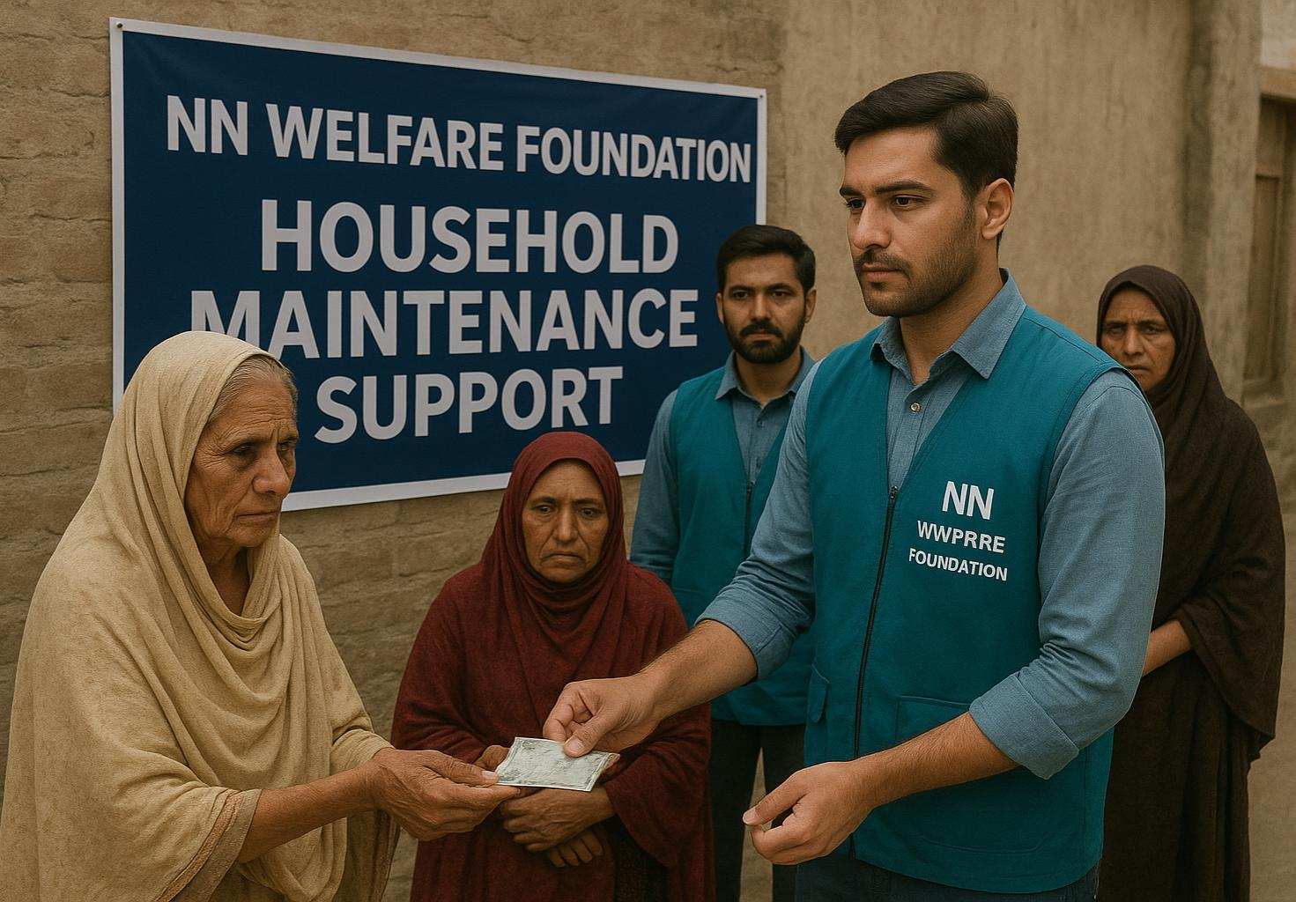
Figure 3 : House Hold Maintenance Support
Scholarships for Higher Education
NNF strongly believes that education is the key to lasting social change. The Scholarship Programme supports bright students from low-income backgrounds by covering tuition fees, books, and academic expenses. This helps young individuals pursue higher education without financial constraints and prepares them to become agents of positive change in their communities. Students are selected based on merit and need assessment, with oversight from donors and institutional partners.
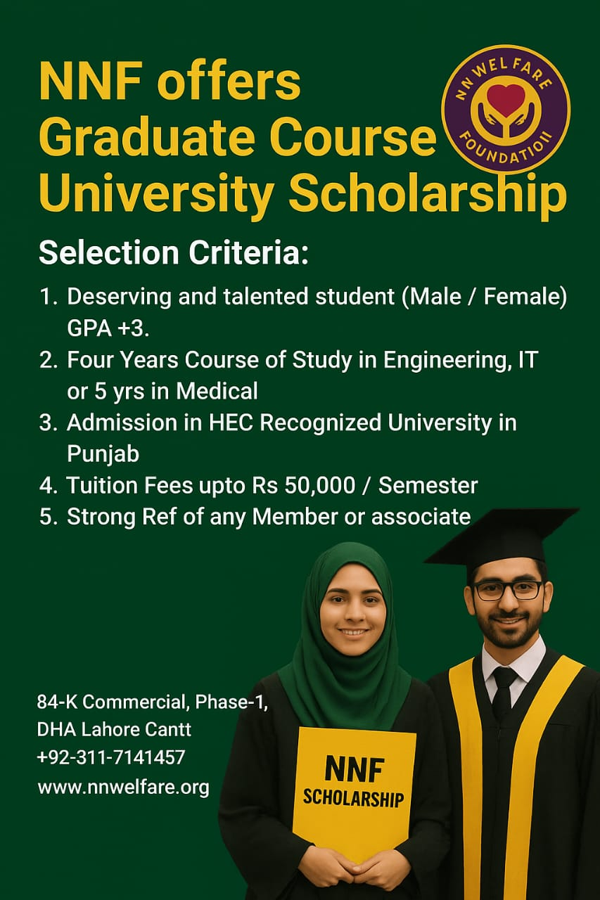
Rehabilitation Support
The Rehabilitation Support Programme focuses on rebuilding the livelihoods and self-esteem of individuals or families affected by financial hardship or job loss. NNF provides structured guidance, training, and small-scale assistance to help beneficiaries restore income sources and achieve independence. The goal is to move individuals from dependence to self-reliance, promoting long-term empowerment.This initiative symbolizes NNF’s belief that true welfare lies not in temporary relief but in helping people reclaim stability and confidence.
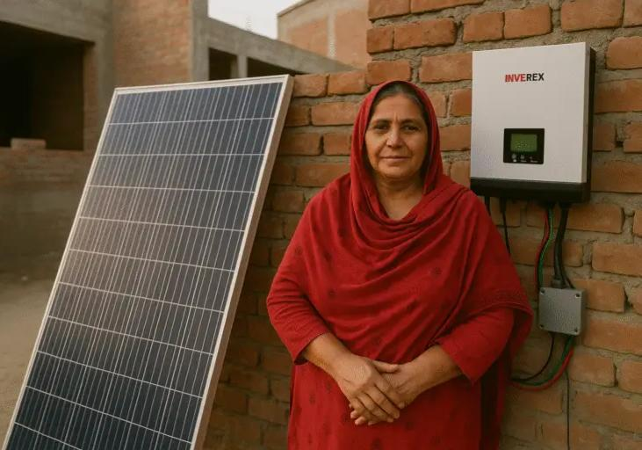
Emergency Relief
NNF’s Emergency Relief Programme provides immediate aid during natural disasters, emergencies, or crises. The Foundation responds swiftly with food, shelter, clothing, and medical supplies to support affected families. All relief operations are coordinated with local authorities and volunteers to ensure transparency, speed, and effectiveness.
This programme reflects NNF’s commitment to standing with communities in their most difficult times—offering compassion, care, and comfort when it matters most.
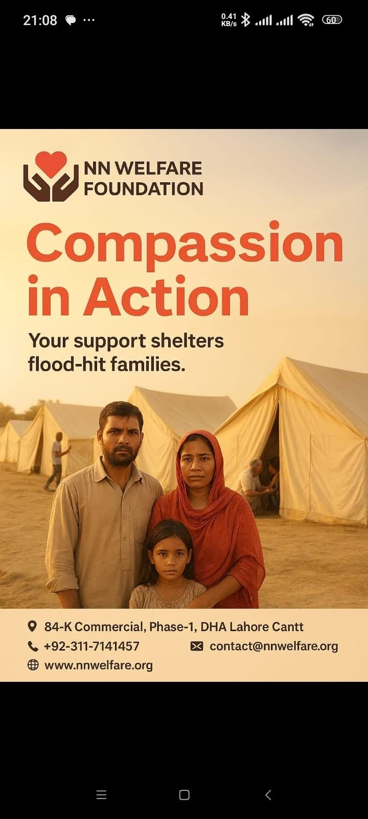
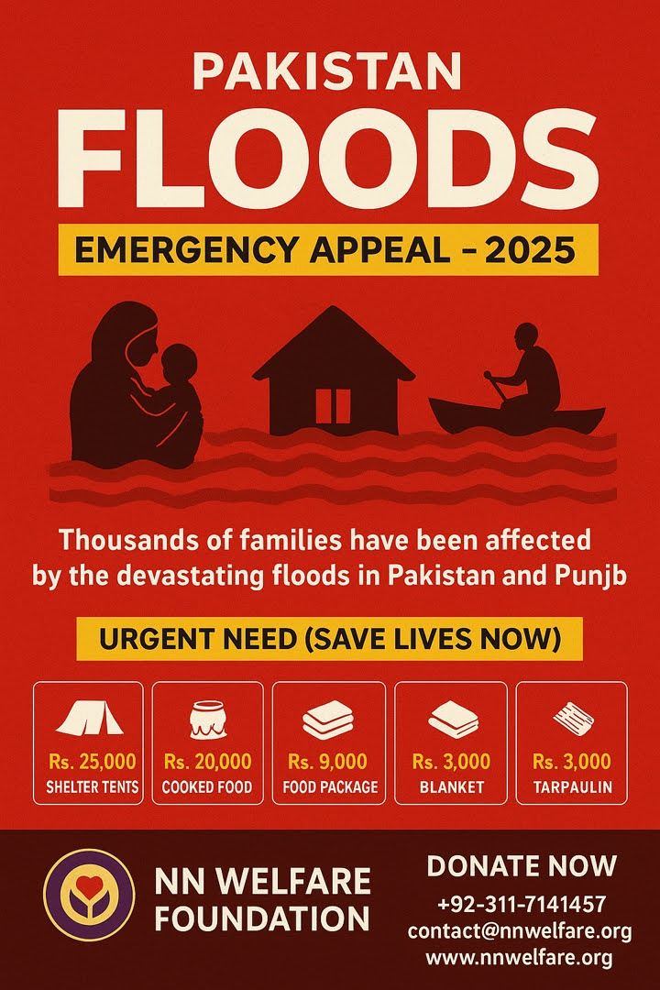

Microfinance / Qarz-e-Hasna (قرضِ حسنہ)
The Qarz-e-Hasna Programme provides interest-free financial support to hardworking and deserving individuals who wish to start or expand small businesses. Beneficiaries receive recoverable loans of up to Rs. 100,000, repayable in easy installments. This initiative fosters economic empowerment and promotes entrepreneurship in low-income communities.
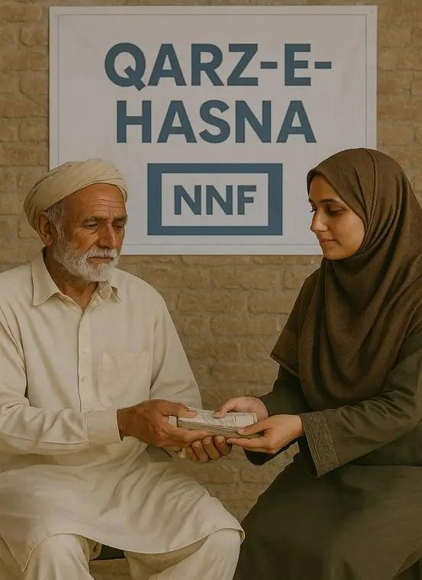
By encouraging self-reliance and accountability, NNF’s Qarz-e-Hasna initiative creates a cycle of empowerment—where today’s beneficiaries become tomorrow’s⁰ donors.

CHAPTER 3

ACHIEVMENTS AND MILESTONE

3.1 Testimonials & Success Stories
Stories of lives transformed through faith, collective generosity, and organized compassion. Each reflects how NNF’s welfare programmes create lasting change — moving individuals from dependence to dignity.
- Career Building with Excellence — Umar Waseem

Education is not preparation for life; education is life itself.”
Umar Waseem, once a struggling engineering student, received NNF’s scholarship support to complete his degree. Today he serves as a project engineer and mentors students in digital processes for NGOs — proof that education creates ripples of empowerment.
My Message to the youth:

“Never stop believing in yourself—support is out there, go and catch the opportunity for improving self, family and the community.”
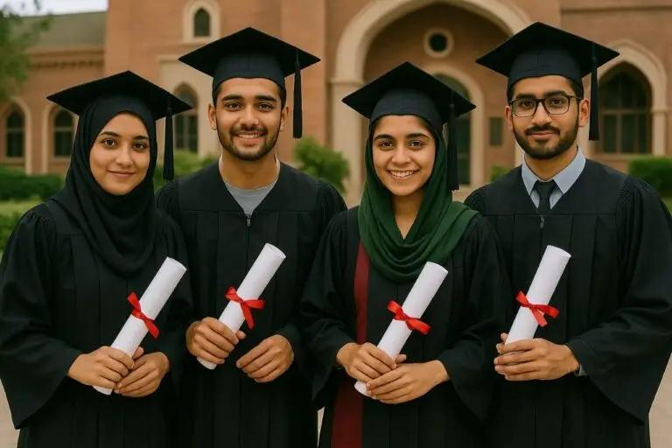
- Empowering Families — Mrs. Khalida
Mrs. Khalida’s family benefited from NNF’s household maintenance support, enabling installation of a solar unit that reduced living costs and improved her children’s study conditions. This life-changing support provided by NN Welfare Foundation, made her home livable, free from the supply of Electricity by the power company. The solar system has not only provided her with a sense of security but also allowed her to redirect the saved Utility Bills and rental expenses towards her children’s education. We extend our deepest gratitude to our donors, whose empathy and kindness have made a tangible difference. Their contribution has empowered her to build a better future for herself and the family, helping them achieve self-reliance and dignity.
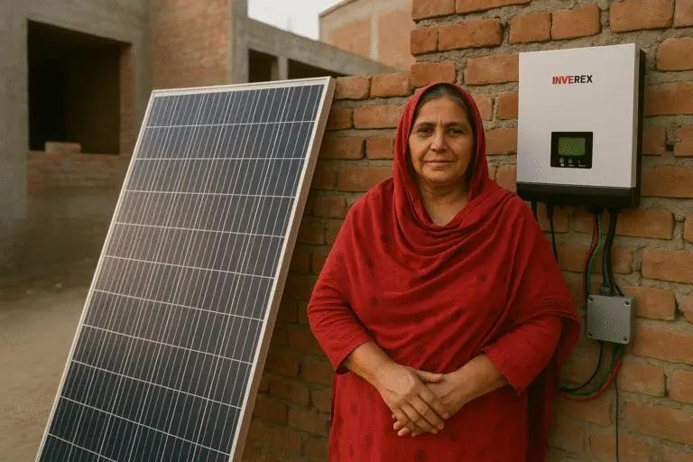
- Empowering Families — Mrs. Rabia
Mrs. Rabia, a hospital attendant, used donor support to complete her home’s structure — freeing her from rental expenses and securing a better future for her children. Thanks to NN Welfare Foundation Donors, her family can now focus on building a brighter future. The savings on rental expenses will be channeled into the children’s education, empowering them to break the cycle of poverty.
This success story showcases the power of collaborative giving and the ripple effect of kindness. The impact goes beyond just a physical structure – it has given the family a sense of stability, security and hope for a brighter future.
- Microfinance Makes a Big Difference — Mr. Boota
Through NNF’s Qarz-e-Hasna Programme, Mr. Boota refurbished his rickshaw, restoring his income and dignity. Thanks to NN Welfare Foundation’s microfinance initiative and ongoing support, Mr. Boota’s family can now look forward to a brighter future. This success story showcases the positive impact of collective efforts and the difference that microfinance can make in the lives of individuals and families in need.
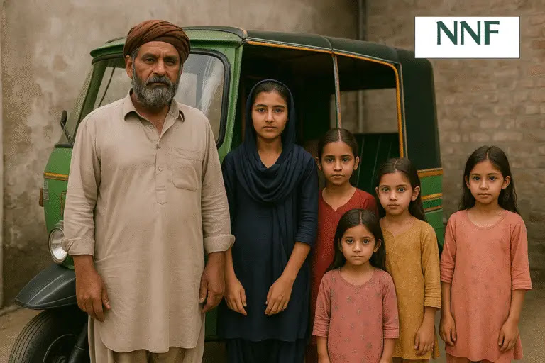

3.2 Events & Impact
NNF has consistently organized impactful events since 2021 — uniting donors, volunteers, and communities. Key initiatives include:
- Ration Distribution Drives: Monthly outreach in low-income areas ensuring food security.
- Scholarship Award Ceremonies: Recognizing merit and motivating students toward excellence.
- Rehabilitation Campaigns: Supporting individuals affected by job loss or medical emergencies.
- Emergency Relief Operations: Swift aid during floods and crises in collaboration with partner NGOs.
- Volunteer Engagement Sessions: Training youth for community service and leadership.
Each event embodies the Foundation’s belief that collective compassion is the strongest form of social capital.

3.3 Key Statistics and Growth Indicators (2021–2025)
NNF’s growth reflects a disciplined, transparent approach that builds trust among donors and dignity among recipients.
Category | Achievements (Approx.)
Families Supported Monthly | 100 +
Scholarships Awarded | 50 + students
Microfinance Beneficiaries | 20 + entrepreneurs
Emergency Relief Cases | 200 + families
Active Volunteers | 70 +
Total Community Outreach | Across 6 cities of Pakistan

CHAPTER 4
Social Media Outreach
Social media is the digital heartbeat of NN Welfare Foundation’s outreach. Through consistent and creative online engagement, NNF spreads messages of hope, transparency, and empowerment to audiences across Pakistan and beyond.
Each visual campaign reflects the Foundation’s identity — faith-driven, service-oriented, and community-focused. Posters and brochures are designed to highlight core programmes, emergency appeals, donor recognitions, and success stories.
Key Campaign Highlights (2021 – 2025):
- “From Blessing to Giving” – Encouraging donors to transform gratitude into action.
- “Faith in Action” – A Ramadan-themed digital drive promoting zakat transparency.
- “Education Empowers” – A nationwide awareness post series spotlighting scholarship recipients.
- “Together We Rise” – Community-outreach campaign featuring volunteers and rehabilitation projects.
- “Relief in Motion” – Emergency appeal visuals during flood and disaster response.

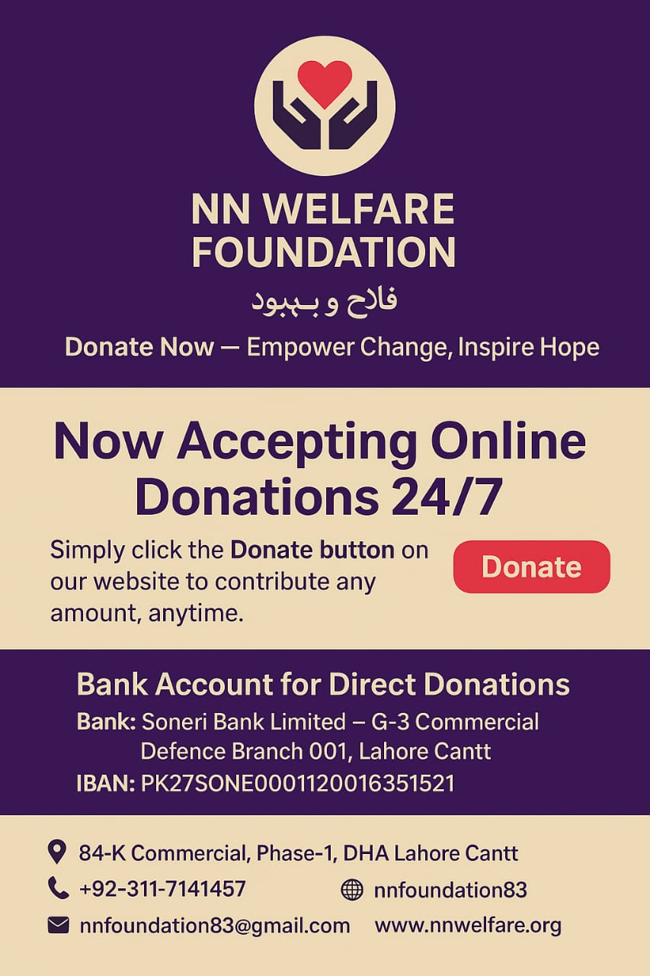

4.2 Taglines and Thematic Messages
Over time, NNF has developed a unique voice that blends spirituality with professionalism. Its taglines serve not only as campaign slogans but as reflections of purpose and identity.
- “Empowering Lives with Dignity.”
- “Faith in Action.”
- “Compassion that Sustains
- “Education – The True Investment.”
- “Small Effort, Great Reward.”
- “Transparency Builds Trust.”
- “Together We Serve – Together We Succeed.”
Each phrase is intentionally brief yet profound, designed to inspire empathy and confidence among donors, volunteers, and beneficiaries alike.

4.3 Digital Engagement Overview
NNF’s online presence spans multiple platforms, including Facebook, Instagram, and WhatsApp Communities, ensuring fast and transparent communication with supporters.
Key engagement practices include:
- Regular posting of verified beneficiary updates.
- Volunteer stories and “Behind-the-Scenes” features.
- Interactive donation links and QR-based contribution tools.
- Event livestreams and recap videos for transparency.
- Educational content promoting zakat and social responsibility.
The Foundation’s digital community has grown organically — building trust through authenticity, humility, and consistent storytelling.
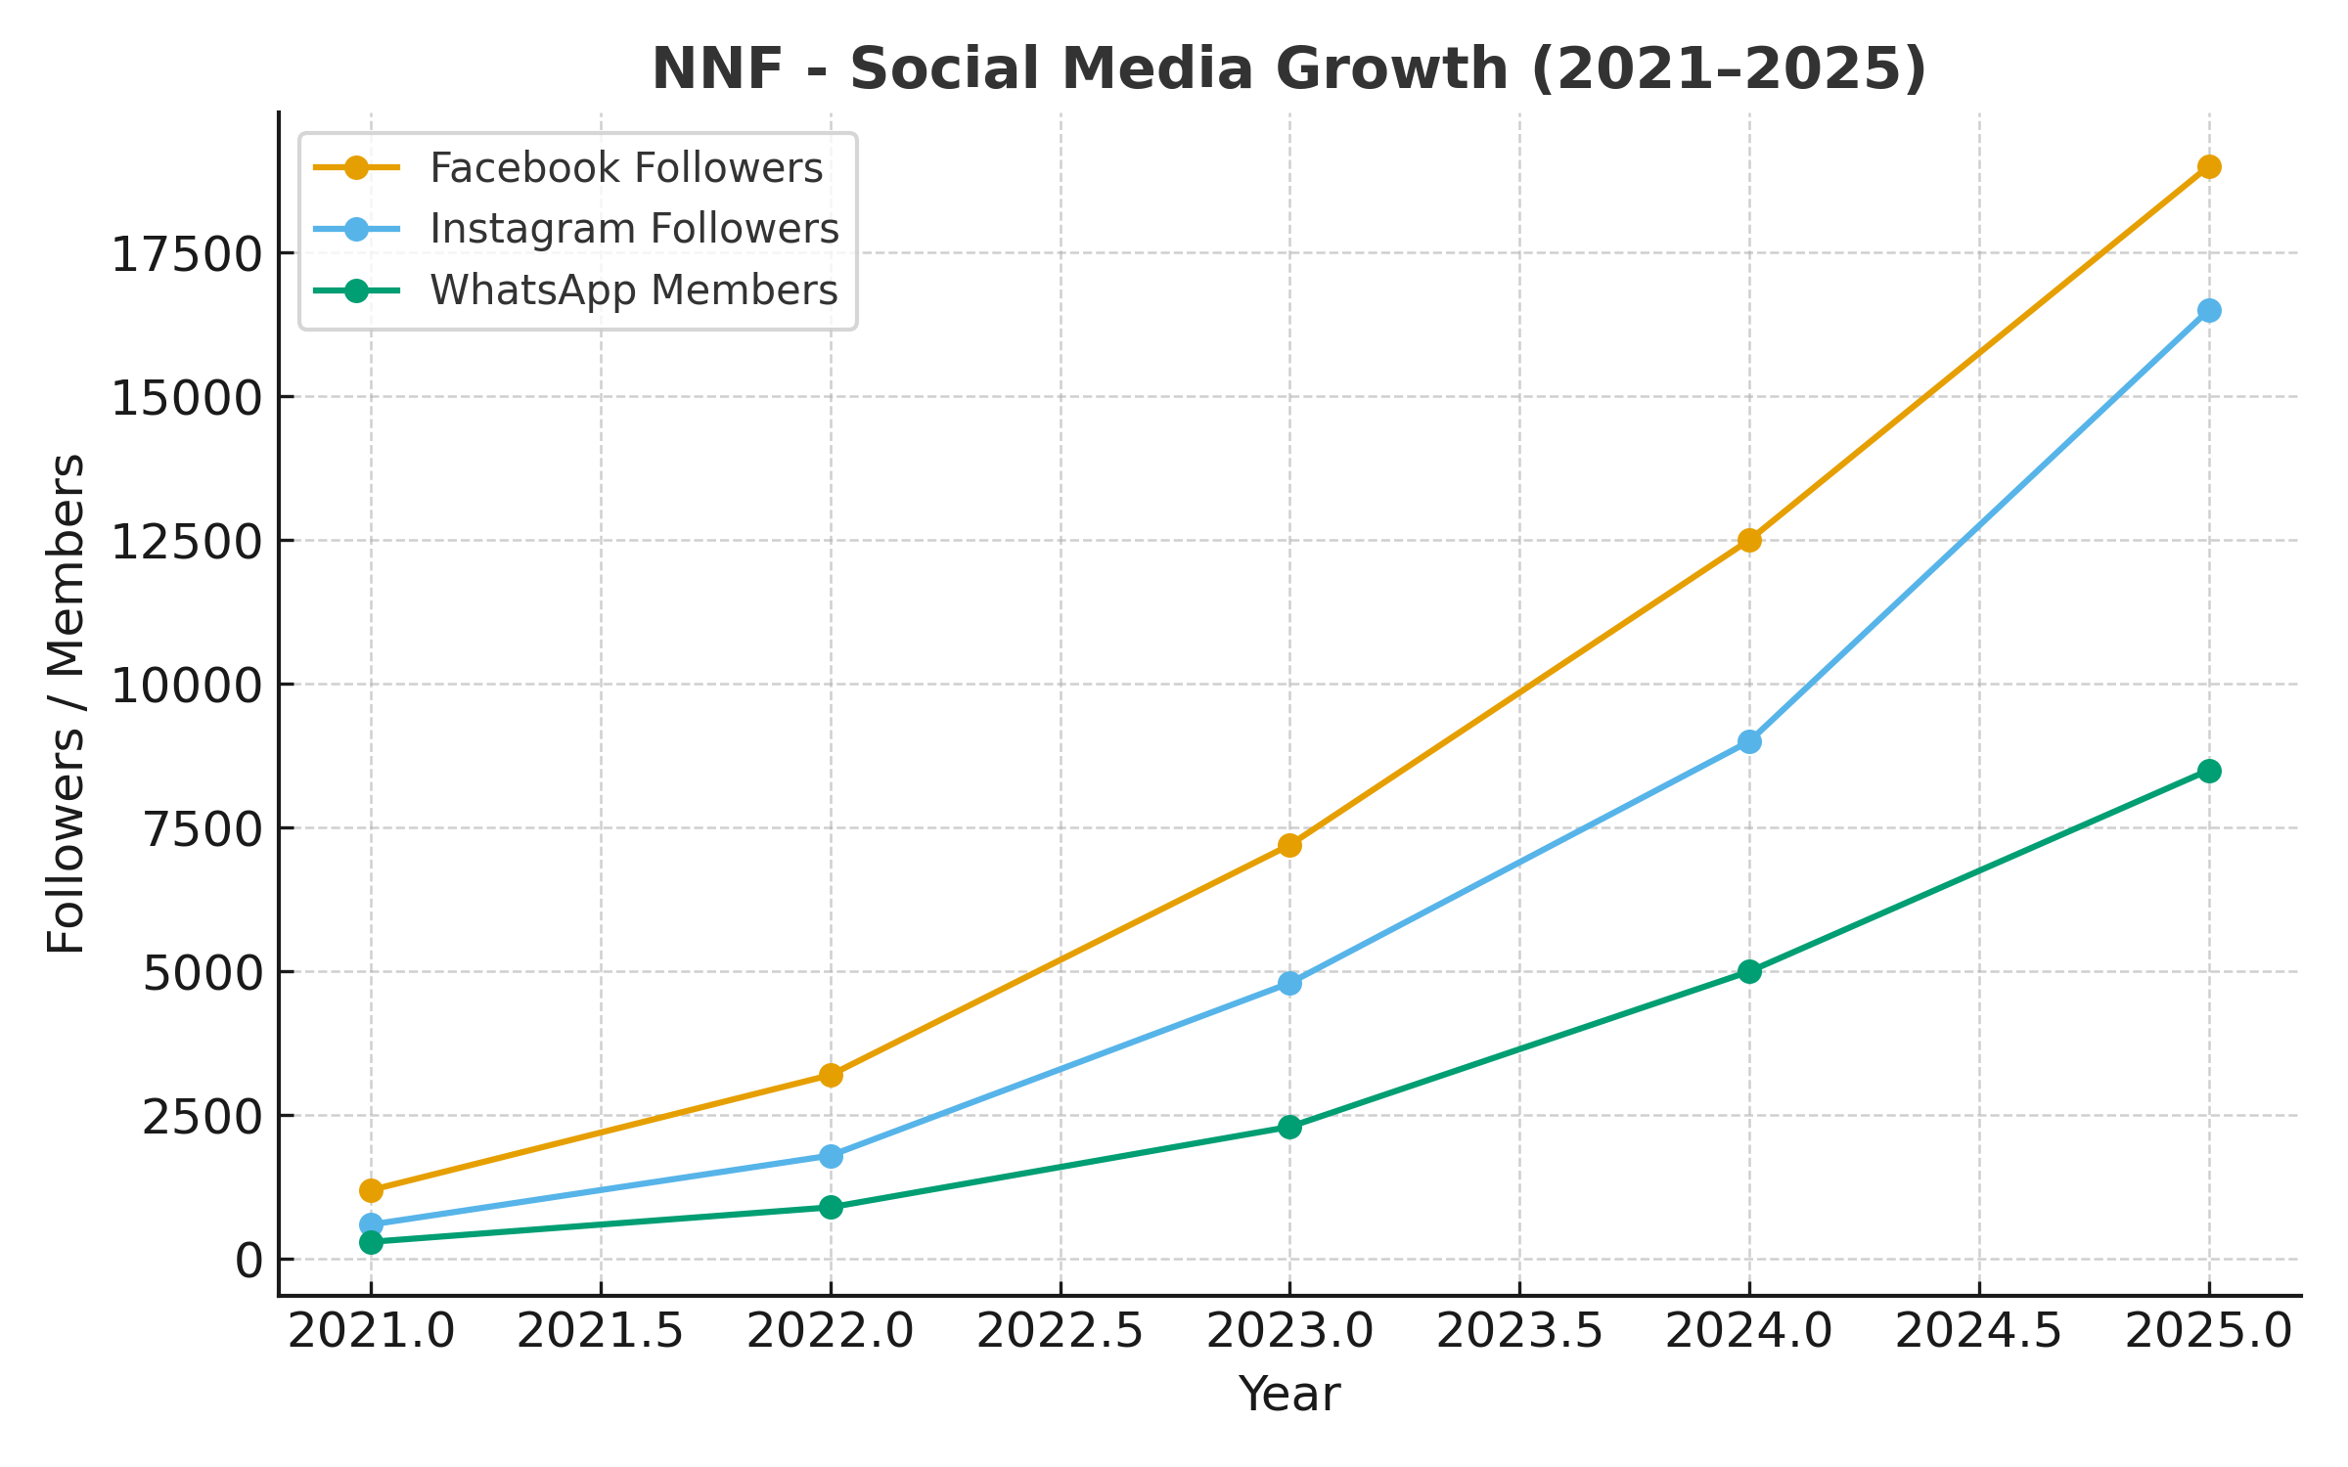
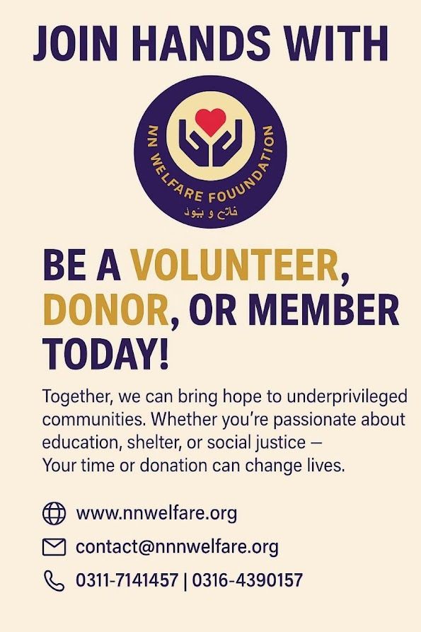

Closing Note
“In today’s connected world, a single image can carry a thousand acts of compassion.”NN Welfare Foundation’s digital footprint serves as a living record of service — documenting each step of its mission and inviting others to join the journey of faith-inspired giving.
Founder’s Reflection
As I reflect upon the journey of the NN Welfare Foundation, I am reminded that progress is not measured by numbers, but by the quiet transformation of lives touched by compassion. Each act of giving, however small, restores faith in humanity and bring purpose to our service. This Foundation stands as a collective expression of empathy and discipline — a shared belief that helping others is a privilege granted by grace.
May this record serve as an inspiration to those who will carry this mission forward, with humility, sincerity, and unwavering faith.
Wg Cdr (R) Muazzam Ali Sheikh
Founder, NN Welfare Foundation
In Gratitude
With humble thanks to Almighty Allah for granting the strength and opportunity to serve.
Every step of this journey — every donation, every volunteer act, and every life uplifted — is a reflection of divine mercy and guidance.
To all who have shared this mission — donors, supporters, and well-wishers — your compassion continues to sustain and inspire the Foundation’s work.
May this spirit of unity and goodwill remain our guiding force for all future endeavours.
Contact Information
- NN Welfare Foundation
- 84-K Commercial, DHA Lahore
- +92-311-7141457
- info@nnwelfare.org
- www.nnwelfare.org
BANK ACCOUNT DETAILS:
- Soneri Bank. Branch Code 0011
- G-3 Commercial, Phase-1. Defence Lahore Cantt
- IBAN: PK27SONE0001120016351521.

